Ideation Phase
Define the Problem Statements

Date | 19 June 2025
Team ID | LTVIP2026TMIDS34741
Project Name | Freelance finder
Maximum Marks | 2 Marks

Customer Problem Statement Template:
To define the core problems freelancers face while searching for jobs online, and use those insights to guide the development of Freelance Finder.
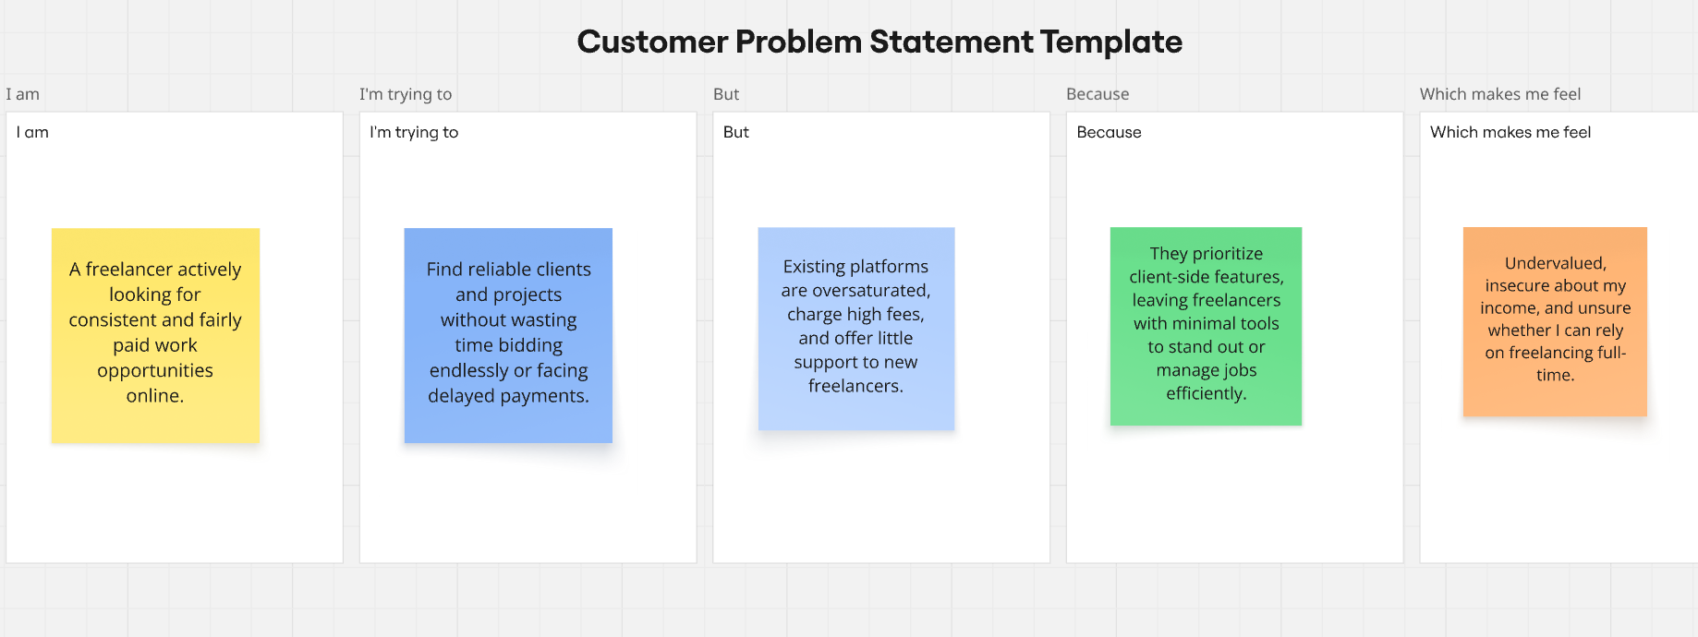
Reference: https://miro.com/templates/customer-problem-statement/

Problem Statement (PS) | I am (Customer) | I’m trying to | But | Because | Which makes me feel
PS-1 | freelance web developer. | land steady projects | competition on mainstream platforms is overwhelming | many clients opt for the cheapest bid | frustrated and demotivated.
PS-2 | freelance graphic designer | showcase my portfolio to potential clients effectively, | platform limits personal branding tools |  | I can't stand out or grow my career.

